
NPRT630 – PROJECT
PROJECT ROADMAP / 04
PHASE 4
Implementation,
Testing & Report
BUILD. TEST. REFINE.

NSNP Food Distribution & Tracking System
Live site: https://nsnp-food-tracking-gvv4.onrender.com/
 | Student Number | Surname | First Name
1 | 202402708 | Mokoena | Karabo
2 | 202306895 | Molomo | Karabo
3 | 202420029 | Thabethe | Kamohelo
4 | 202207325 | Thuto | Henderson
Sol Plaatje University · Diploma in ICT · Examiner: Silas Verkijika

Table of Contents

1. Introduction and Phase 4 Overview 3
1.1 Purpose of this document 3
1.2 Project recap 3
1.3 Access links and demo accounts 3
2. System Implementation 4
2.1 System overview and workflow 4
2.2 Technology stack 4
2.3 System architecture 4
2.4 Database implementation 5
2.5 Feature walkthrough 5
2.5.1 Authentication and profile 6
2.5.2 Delivery Driver 7
2.5.3 School Staff 8
2.5.4 Nutrition Programme Manager 9
2.5.5 Shared features 11
2.5.6 Administration (Django admin) 12
2.6 Traceability to Phase 2 requirements 12
2.7 Non-functional requirements 13
2.8 Deployment 13
3. Changes from Phases 1–3 to the Final System 14
3.1 Change register 14
3.2 Differences between planned and implemented design 15
4. Code Quality, Version Control and Execution 16
4.1 Code organisation 16
4.2 Readability and documentation 16
4.3 Version control 17
4.4 Environment configuration 17
4.5 Execution instructions 17
5. Error Handling 19
6. Testing and Evaluation 21
6.1 Testing strategy 21
6.2 Automated test results 21
6.3 Defects and gaps found by testing 22
6.4 User feedback and usability evaluation 23
6.5 Compatibility, performance and contrast 25
7. Demonstration 27
8. Results and Discussion 28
9. Limitations and Future Improvements 29
9.1 Limitations 29
9.2 Future improvements 29
10. Reflection: Designing for Humans 30
10.1 What we learned 30
10.2 What surprised us 30
10.3 What we would change based on user feedback 30
10.4 Group contributions 30
11. Conclusion 31
References 32

1. Introduction and Phase 4 Overview

1.1 Purpose of this document
This report documents the final stage of our NSNP Food Distribution and Tracking System project. It brings together the system we implemented, the tests we ran, the main results, the remaining limitations and what we learned across Phases 1 to 4.
Some features changed during development. Section 3 explains the main differences between our original designs and the final application so the report reflects what we actually built.

1.2 Project recap
Our project focuses on problems that can happen when school food deliveries and stock are recorded in paper registers or reported by phone. Records can be incomplete, shortages may be reported late, and it can be difficult to check who handled a delivery (Department of Basic Education, 2024; Qila and Tyilo, 2014). We developed a web application with separate dashboards for drivers, school staff and the nutrition programme manager to make delivery and stock information easier to manage.
How the project developed across the four phases
Phase | What was produced | Where it appears in the final system
1. Problem definition | Manual NSNP tracking problem (paper registers, phone calls, no accountability); existing-system review; five-part proposed solution. | Pain points compared with the delivered system in Section 8.1.
2. Analysis & design | Six business processes, eight non-functional requirement groups with measurable targets, eleven functional requirements, UML diagrams. | Requirement-by-requirement status in Sections 2.6 and 2.7.
3. Prototype & data design | Role-based mock-ups, feedback from three reviewers, a 12-entity ERD and a planned database approach. | Feedback is compared with the final system in Section 6.4; the difference between the planned ERD and implemented models is explained in Section 3.
4. Implementation & testing | Deployed Django system on Render, automated testing, error handling, usability feedback review and reflection. | Sections 2 to 10; the report distinguishes completed tests from usability and performance checks not measured.

1.3 Access links and demo accounts
Item | Detail
Live website | https://nsnp-food-tracking-gvv4.onrender.com/
Admin page (Django admin) | https://nsnp-food-tracking-gvv4.onrender.com/admin/
GitHub repository | https://github.com/Karabo-mokena/nsnp-food-tracking
Video demonstration | Recorded 12 October 2026: Watch the demo video (SharePoint). Sequence described in Section 7.1.

Note on the two login systems. The application itself authenticates against its own UserProfile table (session-based login at /). The Django admin site at /admin/ uses Django's built-in users, so it needs a separate superuser created with python manage.py createsuperuser. Only the UserProfile model is registered in the admin.

2. System Implementation

2.1 System overview and workflow
- Manager creates a delivery (school, district, food, quantity, date/time, recipient, driver); the driver is notified.
- Driver sees assigned and self-logged deliveries, marks them Completed or Delayed, and can report issues with a photo.
- School staff confirm receipt for their school, monitor stock and report shortages.
- Completing a delivery updates inventory automatically; falling below the minimum stock sends managers a low-stock alert.
- Managers review issues, update their status, approve or reject registrations and export PDF, Excel and CSV reports.

2.2 Technology stack
Layer | Technology | Reason
Framework | Python 3, Django 6.1 (MVT; Django Software Foundation, 2026) | Built-in ORM, CSRF protection, sessions, templating and admin.
Database | PostgreSQL on Render (via DATABASE_URL); SQLite locally | Managed production database; zero-setup local development. Replaces the MySQL plan in Phase 3.
Serving | gunicorn, WhiteNoise | Production WSGI server and static file serving.
Front end | Django templates, HTML/CSS (15 stylesheets), Bootstrap Icons, Chart.js | Role-specific responsive pages and report charts.
Reports and uploads | reportlab (PDF), openpyxl (Excel), csv, Pillow | Downloadable reports and issue attachments.
Hosting and tooling | Render (Render, 2026), Git, GitHub | Cloud hosting with deploys from the repository.

2.3 System architecture
The project uses one Django application, projectApp, inside the main project configuration. The code includes database migrations, 25 URL routes, 15 HTML templates and separate CSS files for the main pages. Most request handling is in views.py, which became quite long during development. A create_profile management command is also available to create a manager account.
Authentication. Login uses a custom session: after check_password succeeds, the user id is stored in request.session. Every view calls get_logged_in_user(), which returns the user only if the account exists and is Approved; each view then checks the role and redirects users who open another role's page.
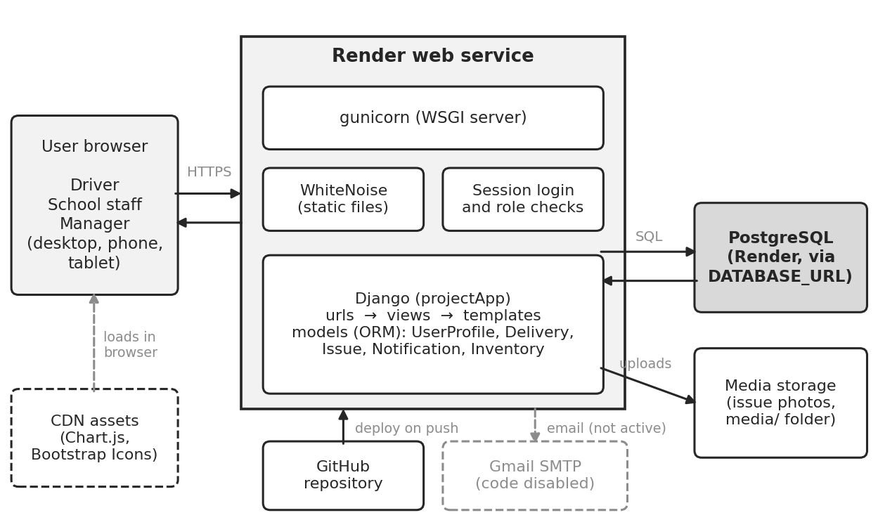
Figure 1: Deployed architecture

2.4 Database implementation
Phase 3 proposed a 12-entity database design. During implementation, we simplified the data structure to five main Django models: UserProfile, Delivery, Issue, Notification and Inventory. This was a practical choice for completing the working prototype, but it means the final database does not fully match the original ERD. Section 3 explains this difference.
Planned entity | Key fields | Planned relationships
SCHOOL | school_id (PK), school_name, location | Parent of USER, DELIVERY, INVENTORYITEM, ISSUE
SUPPLIER | supplier_id (PK), supplier_name, contact_details | Parent of DELIVERY
ROLE | role_id (PK), role_name | Parent of USER
USER | user_id (PK), role_id (FK), school_id (FK), username, password_hash | Child of ROLE and SCHOOL; parent of DELIVERY (driver), USAGERECORD, ISSUE, ALERT, ACTIVITYLOG
DELIVERY | delivery_id (PK), supplier_id (FK), school_id (FK), driver_user_id (FK), delivery_datetime, status | Child of SUPPLIER, SCHOOL and USER; parent of DELIVERYITEM, ISSUE, ALERT
FOODITEM | food_item_id (PK), food_name, unit, category | Parent of DELIVERYITEM and INVENTORYITEM
INVENTORYITEM | inventory_id (PK), food_item_id (FK), school_id (FK), quantity_on_hand, expiry_date | Child of FOODITEM and SCHOOL; parent of USAGERECORD and ISSUE
DELIVERYITEM | delivery_item_id (PK), delivery_id (FK), food_item_id (FK), quantity_delivered | Child of DELIVERY and FOODITEM
USAGERECORD | usage_id (PK), inventory_id (FK), recorded_by_user_id (FK), quantity_used | Child of INVENTORYITEM and USER
ISSUE | issue_id (PK), school_id, reported_by_user_id, delivery_id, inventory_id (all FK), issue_type | Child of SCHOOL, USER, DELIVERY and INVENTORYITEM; parent of ALERT
ALERT | alert_id (PK), user_id, issue_id, delivery_id (all FK), alert_type | Child of USER, ISSUE and DELIVERY
ACTIVITYLOG | log_id (PK), user_id (FK), action, timestamp | Child of USER

2.5 Feature walkthrough
The following sections describe the main screens and how each user role works with the system.

2.5.1 Authentication and profile
- Login (/): username and password; wrong credentials and unapproved accounts show specific messages; users are redirected to the dashboard for their role.
- Registration (/register/): full name, username, email, password and confirmation, role, school, phone and number of learners. Passwords need at least 8 characters with an uppercase letter, a lowercase letter and a digit, with a live strength meter. New accounts stay Pending until a manager approves them; the first manager account is auto-approved so the system can be bootstrapped.
- Forgot password: a modal panel gives guidance (automatic email reset is not available).
- Profile and change password (/profile/, /profile/change-password/): added during implementation.
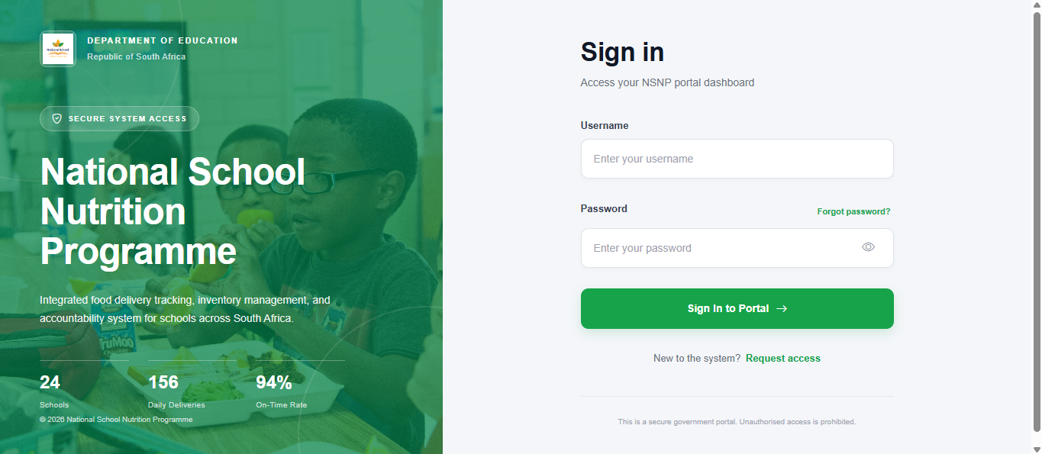
Figure 4: Login screen
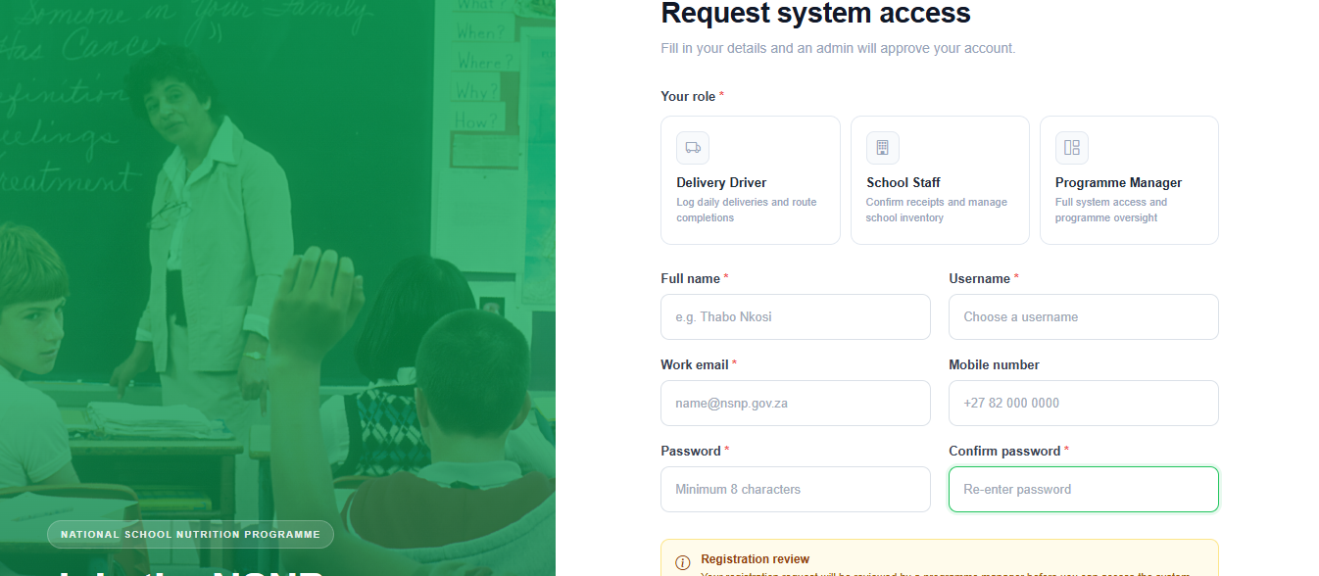
Figure 5: Registration screen
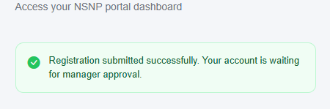
Figure 6: Pending-approval message

2.5.2 Delivery Driver
Business process (Phase 2 §1.1): driver logs in → views today's summary → logs or opens an assigned delivery → marks it Completed or Delayed → reports any problem → tracks the report.
- Dashboard cards: deliveries today, completed, pending, completion percentage, total items and the next pending delivery.
- Delivery form: school, food item, quantity and date. Validation rejects empty fields and quantities that are not positive whole numbers.
- Status buttons: Completed or Delayed. Completing a delivery also updates school inventory and notifies school staff.
- Issues reported by the driver are listed with their status.
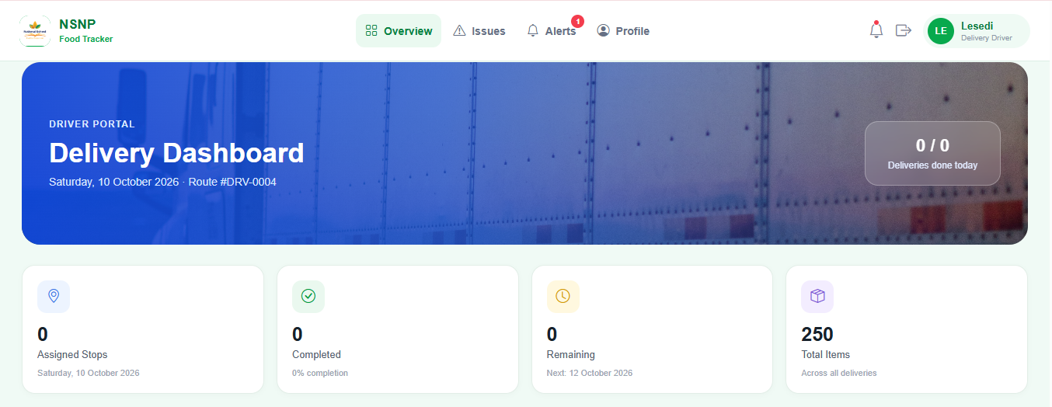
Figure 8: Driver dashboard
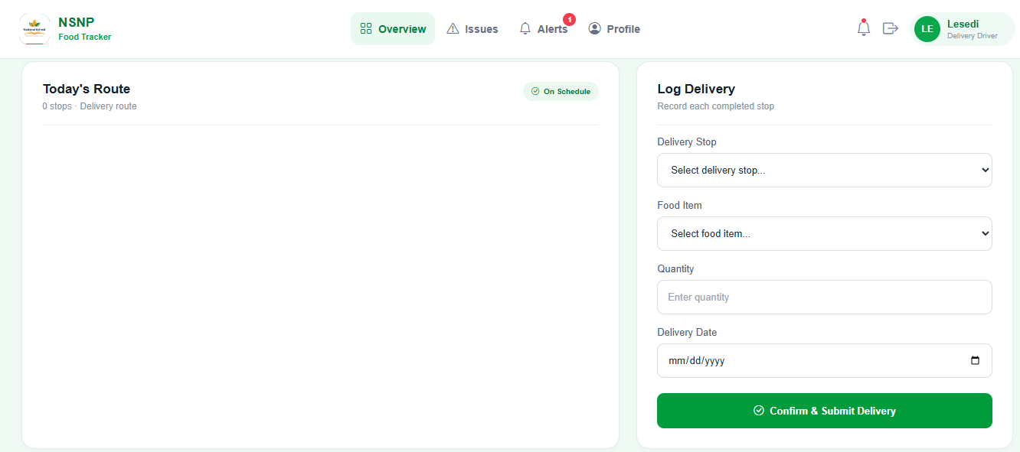
Figure 9: Logging and updating deliveries
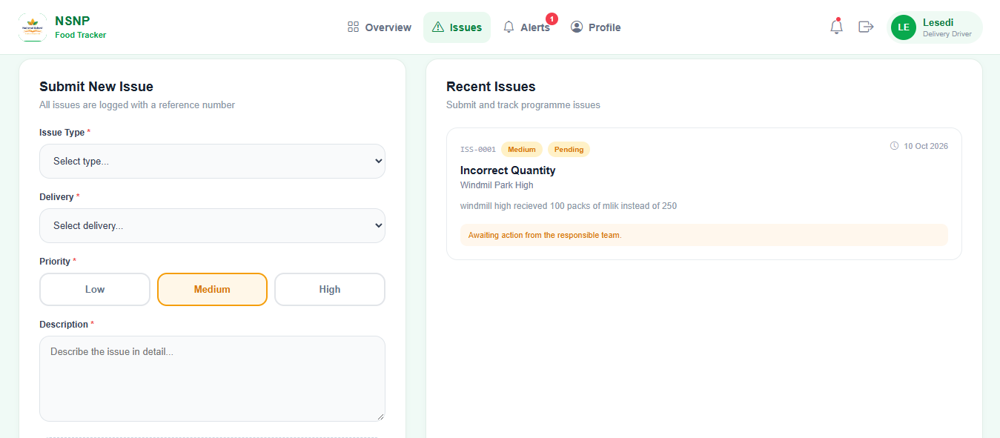
Figure 10: Issue reporting (driver)

2.5.3 School Staff
Business process (Phase 2 §1.2–1.4): staff log in → view pending deliveries → confirm after checking physical stock → monitor inventory → report shortages or damage.
- Dashboard: total, pending and completed deliveries; total inventory; low-stock items; weekly delivery chart; unread notifications.
- Confirm delivery sets the status to Completed and increases stock for the matching food item (or creates a new inventory record).
- Inventory table shows each item with stock level and a Low Stock / Adequate indicator.
- Staff can only confirm pending deliveries for their own school.
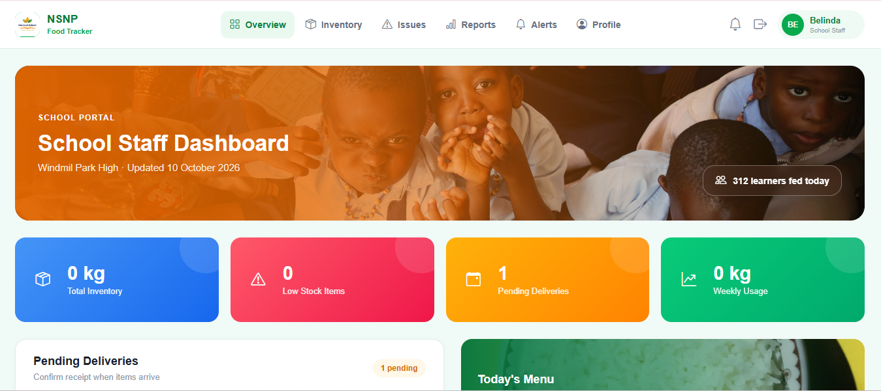
Figure 11: School staff dashboard
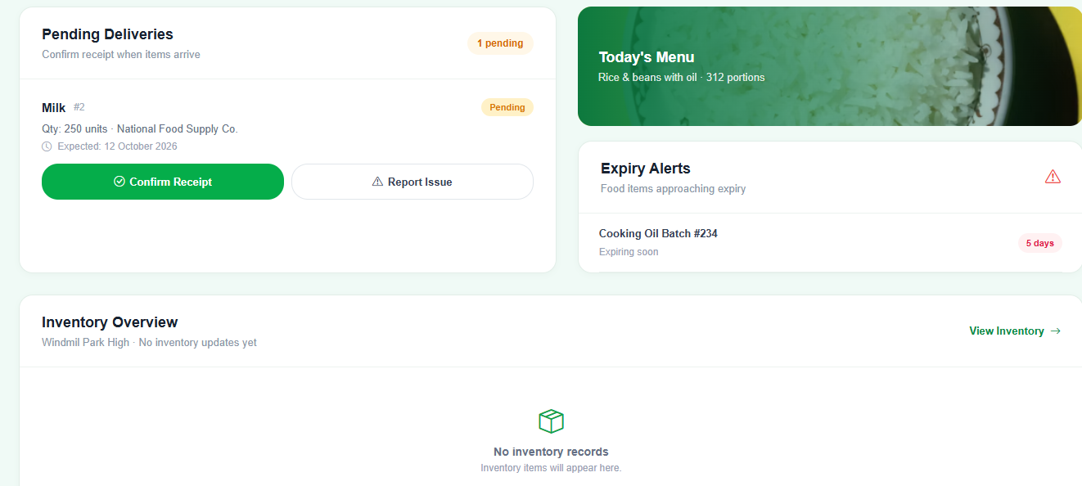
Figure 12: Confirming a delivery
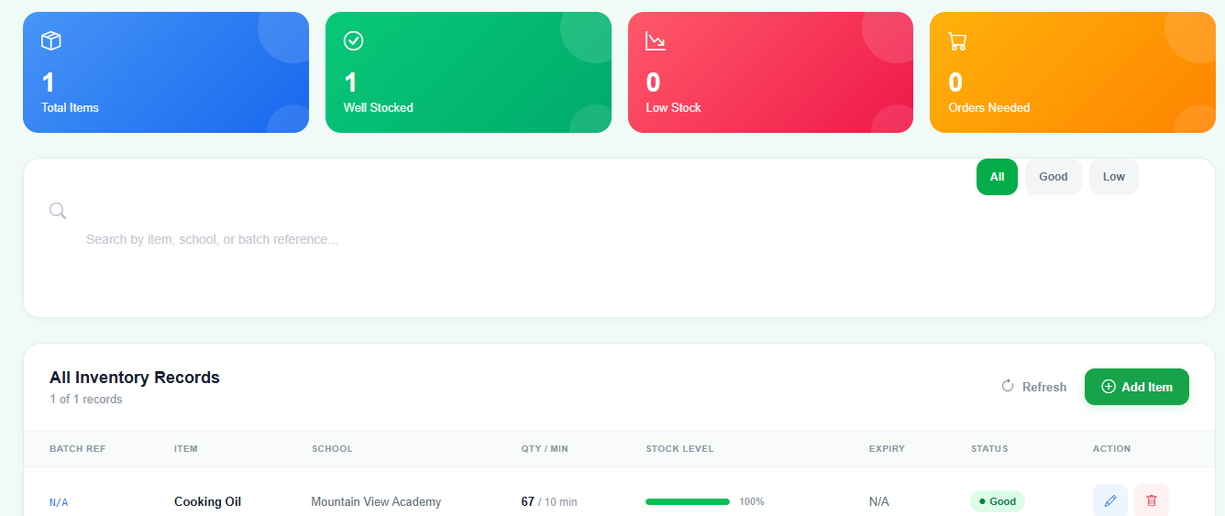
Figure 13: Inventory management

2.5.4 Nutrition Programme Manager
Business process (Phase 2 §1.5): manager logs in → reviews system overview → creates and assigns deliveries → reviews issues → approves users → generates reports.
- Manager dashboard: schools served, active drivers, deliveries today (completed, pending, delayed), overall completion rate, open issues and a delivery activity chart across all schools.
- Create delivery (/deliveries/create/): school, district, food item, quantity, date, optional time, recipient and assigned driver, with the ten most recent deliveries shown beside the form.
- Issue management (/report-issue/): view every report and change its status to Open, In Progress or Resolved. The reporter is notified of each change.
- User management (/user-management/): approve or reject registrations, edit user details and roles, delete users and see user counts by status and role.
- Inventory and Reports (below) are available to managers across all schools.
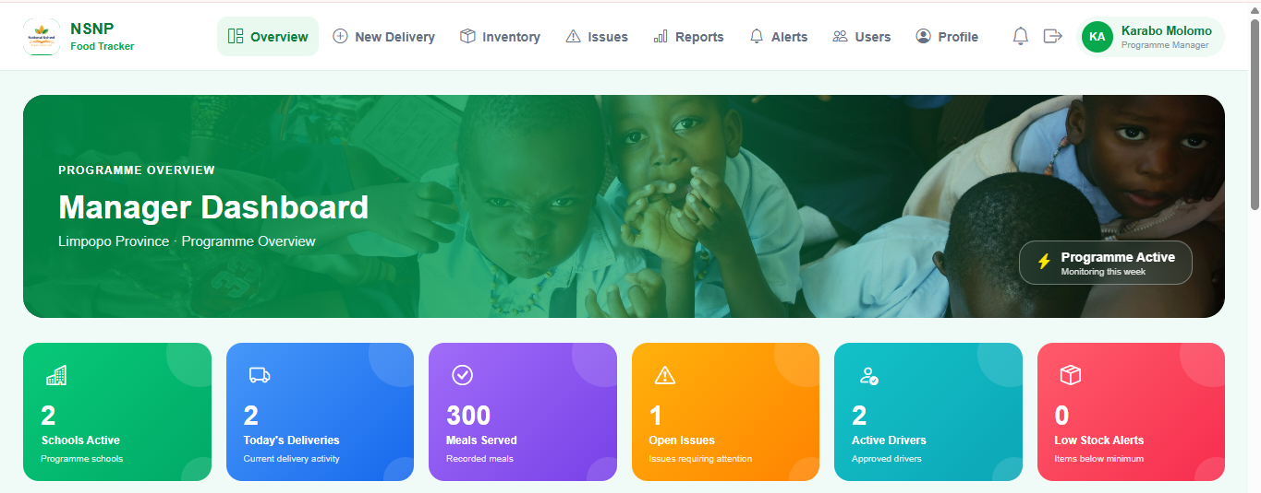
Figure 14: Manager dashboard
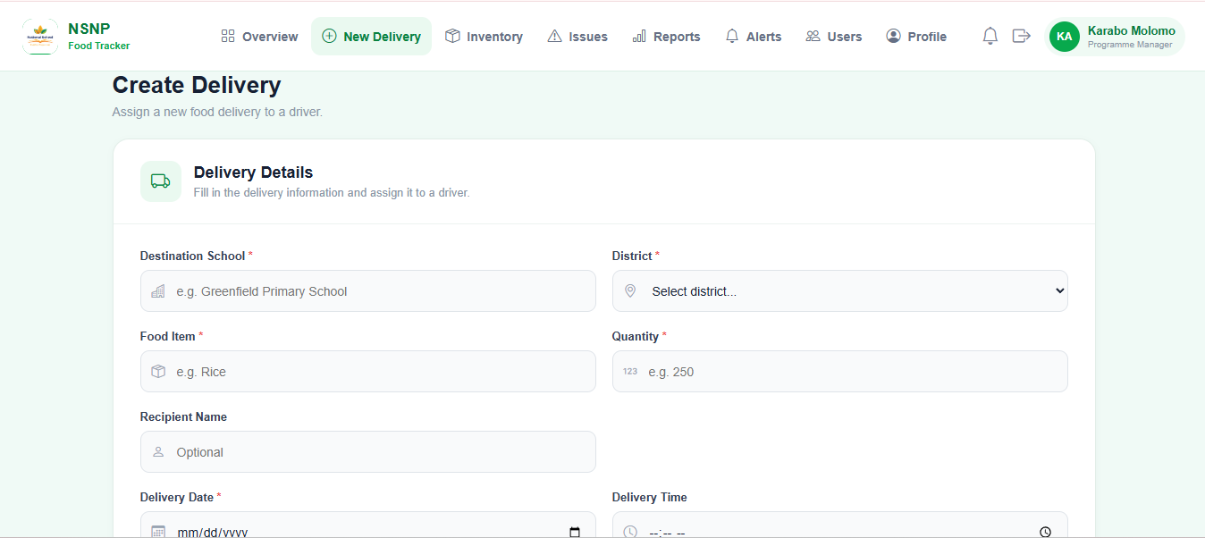
Figure 15: Creating and assigning a delivery

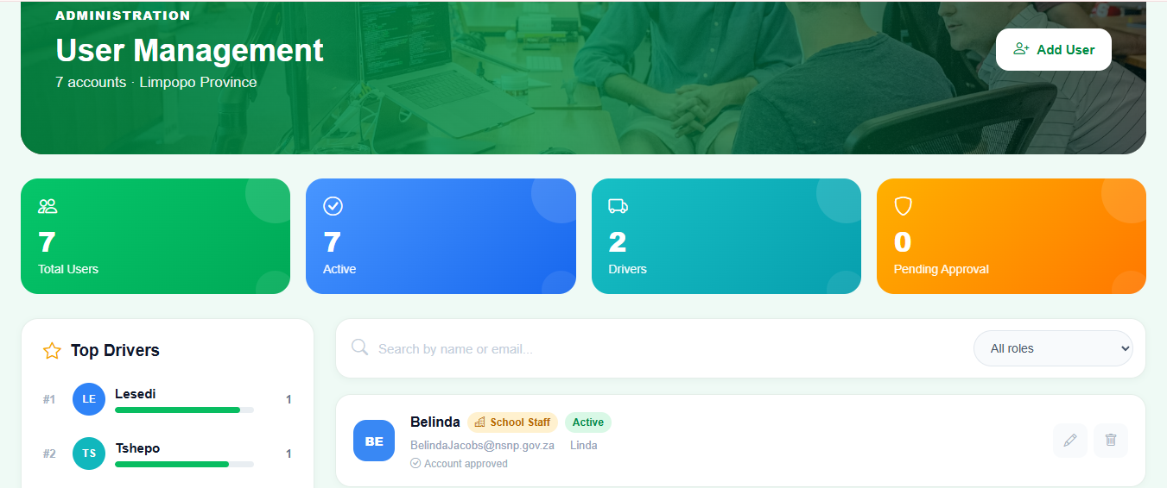
Figure 17: User management and approvals

2.5.5 Shared features
- Notifications (/notifications/): unread badge in the header, mark one or all as read, and alert/delivery/system categories. Updates appear when the page is loaded or refreshed.
- Reports (/reports/, school staff and managers): KPI cards, Chart.js charts for deliveries and inventory, expiring-soon count (items expiring within 10 days) and downloadable PDF, Excel and CSV exports with an optional date range.
- Role-based navigation: each template shows only the links relevant to the signed-in role.
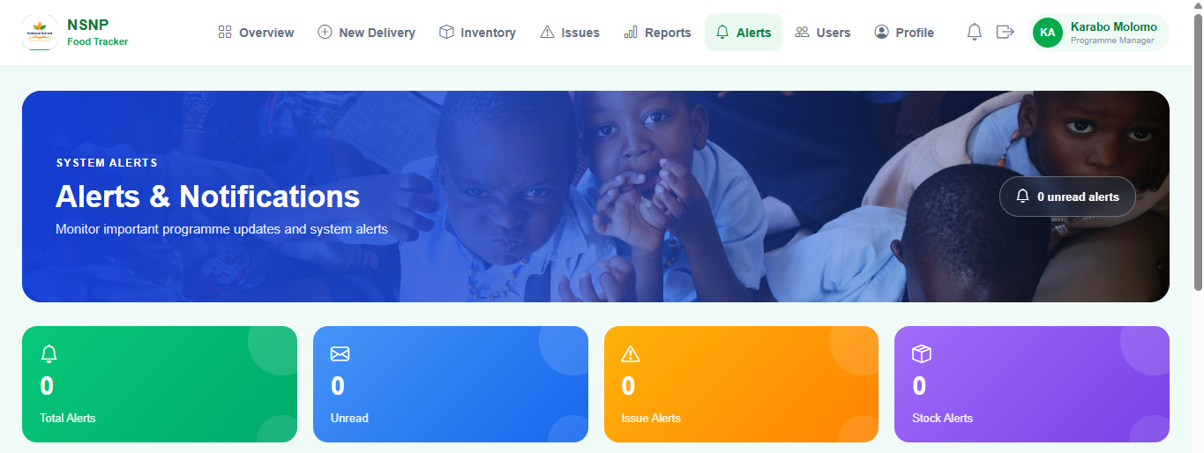
Figure 18: Notification centre
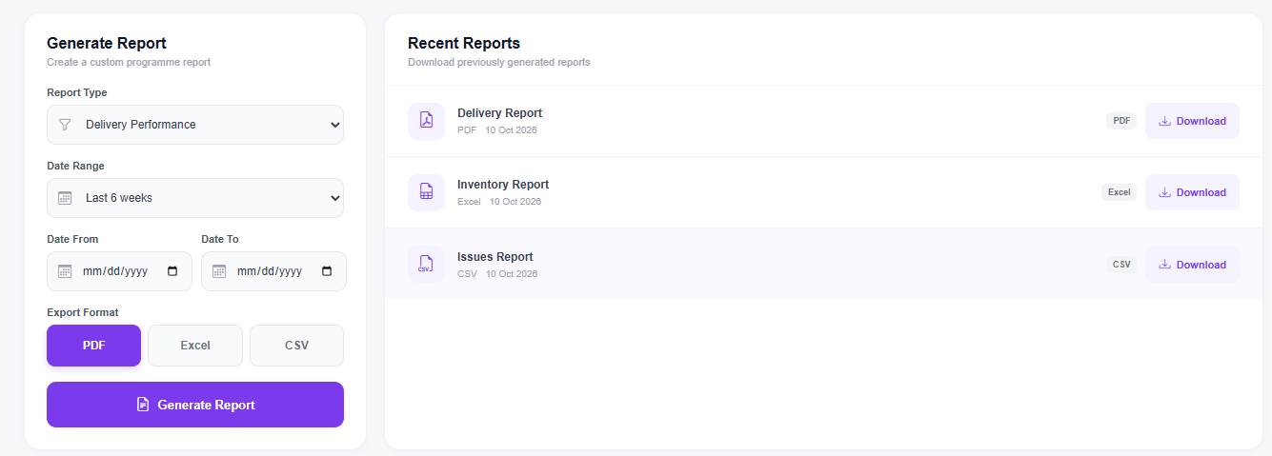
Figure 19: Report generation view
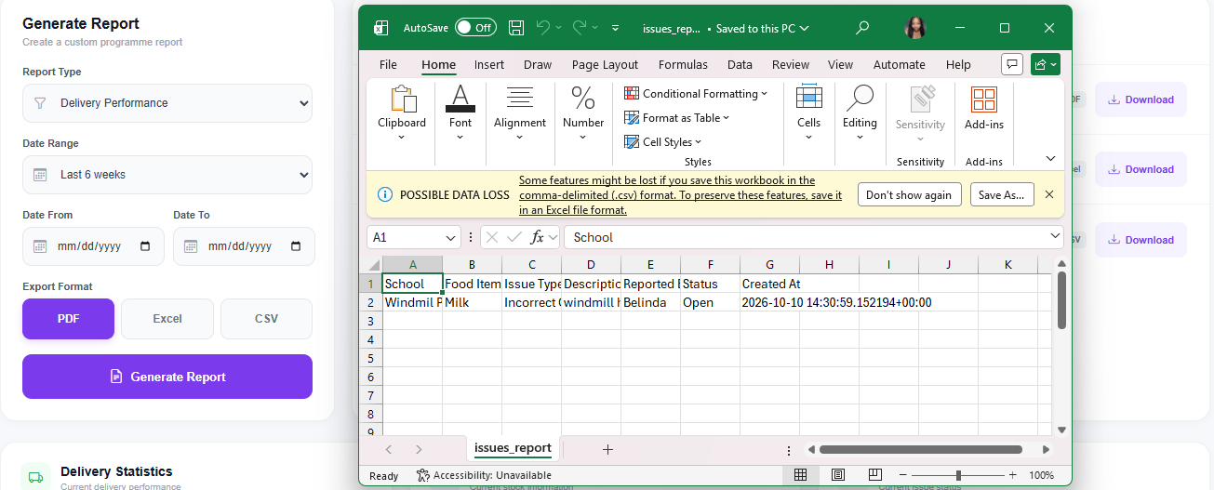
Figure 20: Exported report formats(CSV File)

2.5.6 Administration (Django admin)
The Django admin at /admin/ allows a superuser to view and edit UserProfile records. It is a technical back-office tool; day-to-day user management is done through the manager's User Management page.
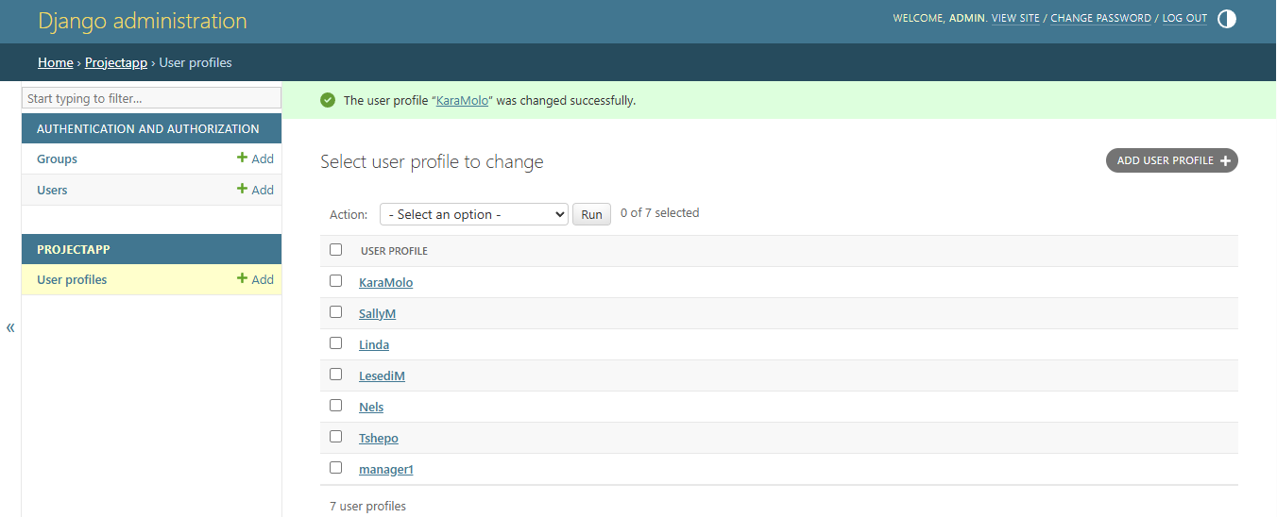
Figure 21: Django admin site

2.6 Traceability to Phase 2 functional requirements
Requirement | Status | Implementation notes
3.1 User authentication | Implemented | Username/password login, role routing, approval required, hashed passwords.
3.2 Delivery logging | Implemented | Driver and manager forms; status starts Pending. Date is entered by the user, not auto-stamped.
3.3 Confirmation and issue handling | Partial | Staff confirm sets Completed and updates stock. Issues use a separate form; the delivery is not flagged "Issue Reported".
3.4 Inventory management | Implemented | Automatic increase on completion plus manual add, edit, delete and search.
3.5 Daily usage recording | Not implemented | No form or screen records usage; stock can only be reduced by editing the quantity.
3.6 Expiry monitoring and alerts | Partial | Expiry dates and days remaining are shown; no automatic notification.
3.7 Issue reporting | Implemented | Type, priority, description and attachment, linked to a delivery.
3.8 Manager notification | Partial | Managers get low-stock alerts; a new issue does not notify them (test confirms).
3.9 Monitoring dashboard | Implemented | Manager dashboard and Reports page aggregate all schools.
3.10 Delay detection | Partial | Delayed status is set manually by the driver; no automatic comparison.
3.11 Activity logging | Not implemented | The application records no activity (test confirms).

2.7 Non-functional requirements: targets versus result
Phase 2 target | Status | Evidence
Passwords encrypted | Met | Django hashing; test TC-08 confirms the stored value differs from the password; TC-38 confirms password changes work.
Role-based access | Met | Role checks in every view; automated access-control tests (Section 6). One gap: the report download endpoint has no role check.
Auto-logout after 5 minutes | Not met | SESSION_COOKIE_AGE is 3600 s (1 hour).
Clear error messages | Partially met | Messages exist (Section 5), but inventory add-form errors are not displayed.
Response under 2 s, dashboard under 5 s, 100 concurrent users | Future testing | Future testing. No load test has been completed yet for response time or 100 concurrent users (Section 6.5).
Availability 99% | Future testing | Future testing. Render hosting was used, but availability has not yet been monitored over a defined period (Section 6.5).
Tasks under 1 minute | Future testing | Future testing. Target from Phase 2; timed post-implementation task trials are planned (Section 6.4).
Maintainable, modular code | Partially met | MVT structure and migrations, but one 2,300-line views.py.
Portable (phones, tablets) | Partially met | Responsive styles are present, but a formal phone and tablet test is future testing (Section 6.5).

2.8 Deployment
The system is deployed on Render and connected to the GitHub repository. The application reads its secret key, debug flag, database URL and email password from environment variables, uses PostgreSQL in production and falls back to SQLite when DATABASE_URL is not set. Static files are collected and served by WhiteNoise, and gunicorn runs the WSGI application.
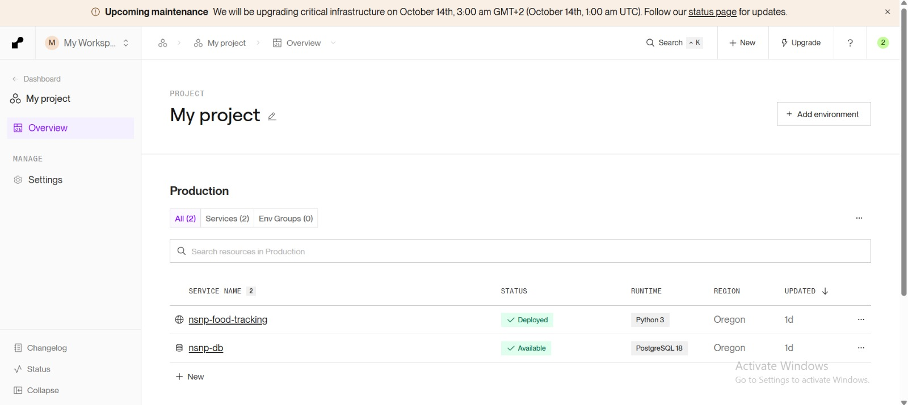
Figure 22: Production deployment on Render

3. Changes from Phases 1–3 to the Final System

3.1 Change register
Area | Planned in Phases 1–3 | Implemented | Status
A. Data and architecture
Database engine | SQLite prototype, MySQL production (Phase 3 §7.1) | SQLite locally, PostgreSQL on Render | Changed
Schema | 12 tables: school, supplier, role, user, delivery, fooditem, inventoryitem, deliveryitem, usagerecord, issue, alert, activitylog (Phase 3, Section 5) | The final application uses five main Django models: UserProfile, Delivery, Issue, Notification and Inventory. | Simplified
B. Authentication and users
Account creation | Admin-issued credentials (prototype); self-registration (iteration) | Self-registration plus manager approval; first manager auto-approved | Changed
Password handling | Passwords encrypted | Hashing plus policy (8+ characters, upper, lower, digit), strength meter, change-password page, forgot-password guidance panel | Added
Session timeout | Logout after 5 minutes idle | 1-hour session, ends when the browser closes | Not implemented
Admin panel | Manager "admin panel" to create accounts | User Management page (approve, reject, edit, delete) plus Django admin for a superuser | Changed
C. Delivery workflow
Who creates deliveries | Driver (Phase 1); manager assigns (Phase 3) | Both: manager assigns with driver, district, time, recipient; driver can also log | Changed
Date and time | System records date and time automatically | Date typed on the form; time optional, manager form only | Changed
Statuses | Pending Confirmation → Confirmed / Issue Reported; manager view adds In Transit | Pending, Completed (shown as "Delivered" to managers), Delayed | Changed
Who confirms receipt | School staff confirm, triggering the inventory update | Staff can confirm and the driver can mark Completed, which also updates stock | Changed
Manager edits delivery | Manager edits or marks delayed | No edit route; driver sets Delayed | Not implemented
Delay detection | Automatic expected vs actual comparison | Manual Delayed status; staff notified | Partial
Driver dashboard | Assigned deliveries and summaries | Today's counts, completion %, next delivery, history, issues | Implemented
D. Inventory
Stock updates | From confirmed deliveries | Automatic on completion plus manual add, edit, delete, search | Implemented
Low-stock alerts | Not specified | Managers alerted once per item, school and day | Added
Expiry alerts | Alerts to staff for near-expiry items | Days remaining shown and counted on Reports; no notification | Partial
Daily usage | Staff record usage; stock deducted | Not built. Staff weekly chart plots deliveries, and "learners fed" is fixed at 312 | Not implemented
E. Issues, notifications and reports
Issue form | Type and details; feedback asked for attachments and severity | Adds priority and attachment (PNG, JPG, PDF, max 10 MB) | Added
Manager alert on new issue | Real-time notification | Not generated; visible on dashboard and issues page | Partial
Notification centre | Real-time notifications | In-app page with unread badge; updates on page load | Changed
Email | Alerts without phone calls (Phase 1) | Code written but disabled; Render free tier blocks SMTP (code comment) | Not active
Reports | Feedback: no structured reports | KPIs, charts, PDF/Excel/CSV export with date filter | Added
F. Platform
Client | Tablet or mobile app; Android and iOS | Responsive web app; no native app | Changed
Hosting and libraries | Django only (Phase 3 §7.2) | Render, gunicorn, WhiteNoise, Chart.js, Bootstrap Icons, reportlab, openpyxl, Pillow, dj-database-url, psycopg2 | Added

3.2 Differences between planned and implemented design
- Phase 3 ERD, entity descriptions and relationships: update needed; the final application uses five main models rather than the 12 entities in the planned ERD
- Phase 3 §7.1: production database is PostgreSQL, not MySQL.
- Phase 2 UML: delivery states are Pending → Completed or Delayed; add user states Pending → Approved or Rejected; show that driver and staff can both complete a delivery.
- Phase 2 NFRs and Phase 1 solution list: mark the 5-minute logout, activity logging, usage tracking and automatic expiry and delay alerts as not met or future work.
- Phase 3 mock-ups: replace "Admin panel" with User Management and add Reports, Inventory, Profile and Notifications.

4. Code Quality, Version Control and Execution

4.1 Code organisation
The project follows the usual Django structure. Request handling is mainly in views.py, page layouts are in templates, styles are stored separately, and database changes are tracked through migrations.
Path | Contents
manage.py | Django command-line entry point.
project/ | Settings, root URL configuration, WSGI and ASGI entry points.
projectApp/models.py | Database models.
projectApp/views.py | All request handlers and helper functions.
projectApp/templates/projectApp/ | 15 page templates.
projectApp/static/css/ | 15 page stylesheets; static/video/ holds a video asset.
projectApp/migrations/ | 14 schema migrations (0001 to 0014).
projectApp/management/commands/ | create_profile seed command.
requirements.txt | Pinned production dependencies.
README.md | Project overview and setup notes.
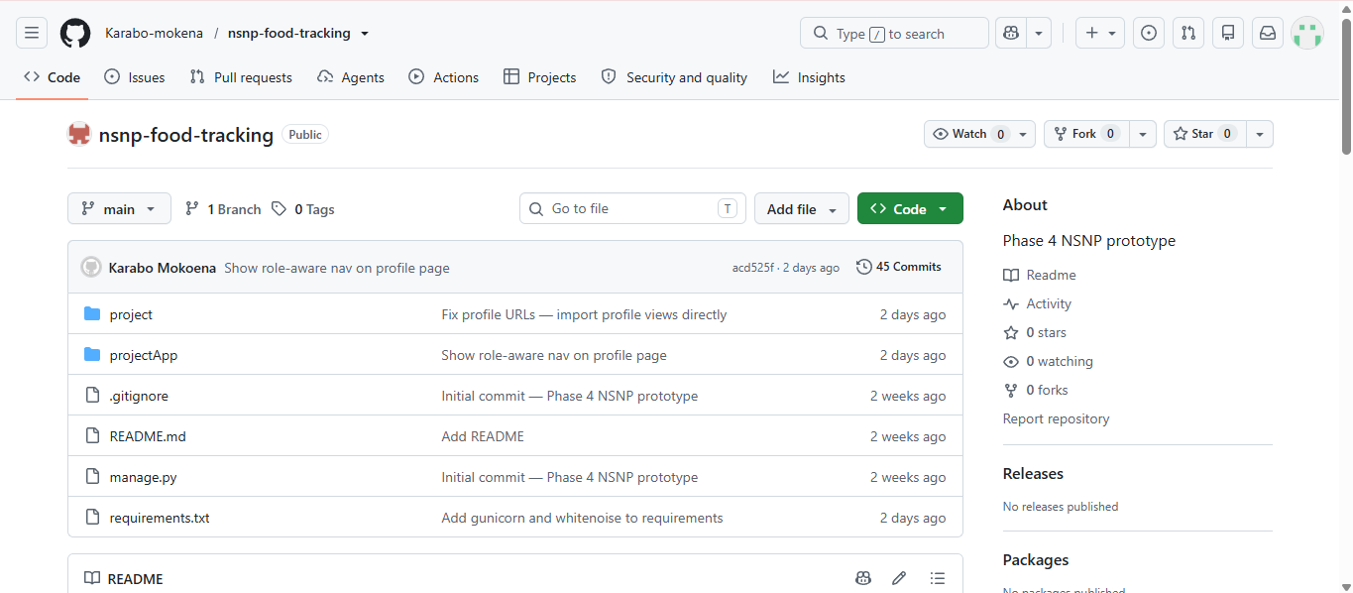
Figure 23: GitHub repository structure

4.2 Readability and documentation
- Function and variable names describe their purpose (for example check_and_alert_low_stock, update_delivery_status_view).
- Shared behaviour is extracted into helpers: get_logged_in_user (session and approval check) and check_and_alert_low_stock (alert once per item, school and day).
- Input is validated before it is saved and errors are returned to the template (Section 5).
- Disabled email code is kept with an explanatory comment stating why it is off.

4.3 Version control
We used GitHub to keep the project files and track changes. The commit history shows the work being added in stages, including deployment configuration, the PostgreSQL connection, registration approval, password validation and profile features.
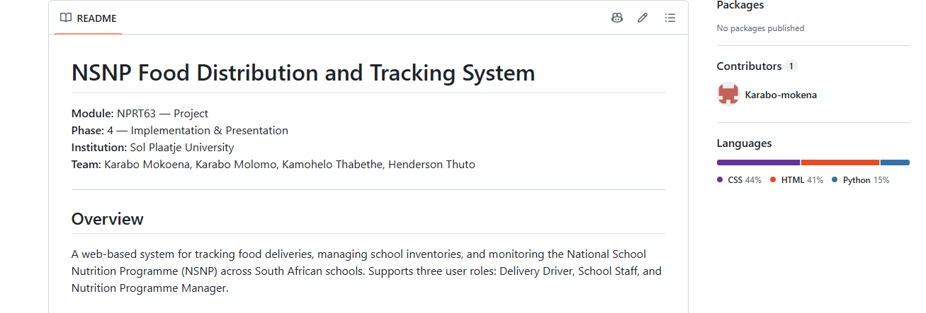
Figure 24: Commit history

4.4 Environment configuration
Variable | Purpose | Default if unset
DJANGO_SECRET_KEY | Cryptographic signing key | Insecure development key in settings.py (must be set in production)
DEBUG | Debug mode (True or False) | False
DATABASE_URL | PostgreSQL connection string (set on Render) | SQLite file db.sqlite3
EMAIL_HOST_PASSWORD | Gmail app password for SMTP | None (email is disabled in the deployed build)

Other settings: time zone Africa/Johannesburg, ALLOWED_HOSTS limited to the Render hostname, localhost and 127.0.0.1, CSRF_TRUSTED_ORIGINS for the Render hostname, MEDIA_ROOT at media/, and session lifetime of one hour.

4.5 Execution instructions

Run locally
- Install Python 3.11 or newer and Git.
- Clone the repository: git clone https://github.com/Karabo-mokena/nsnp-food-tracking.git and cd nsnp-food-tracking.
- Create and activate a virtual environment: python -m venv venv, then venv\Scripts\activate (Windows) or source venv/bin/activate (macOS/Linux).
- Install all dependencies: pip install -r requirements.txt. Use this file rather than installing individual packages, because it also includes gunicorn, WhiteNoise, psycopg2-binary, dj-database-url and Pillow.
- Apply the database migrations: python manage.py migrate.
- Create a manager account: run python manage.py create_profile (seed manager) or register through /register/ as the first manager, who is approved automatically.
- Optional: create a Django admin superuser with python manage.py createsuperuser.
- Start the server: python manage.py runserver, then open http://127.0.0.1:8000/.
- Log in as the manager, register further driver and school staff accounts, and approve them in User Management.

Deploy on Render
- Create a PostgreSQL database and a web service connected to the GitHub repository.
- Set the environment variables listed in Section 4.4 (DATABASE_URL, DJANGO_SECRET_KEY, DEBUG=False).
- Build command: pip install -r requirements.txt && python manage.py collectstatic --noinput && python manage.py migrate
- Start command: gunicorn project.wsgi:application

5. Error Handling
Error handling is implemented in three layers: input validation with user-friendly messages, access control and safe redirects, and defensive handling of missing records or optional dependencies.
Scenario | Handling in the system | Message / behaviour shown
Wrong password | Credentials checked with check_password | "Incorrect password."
Unknown username | UserProfile.DoesNotExist caught | "Username does not exist."
Account not yet approved | Status checked at login and in every session lookup | "Your account is waiting for manager approval."
Passwords do not match | Compared on registration | "Passwords do not match."
Weak password | Length, uppercase, lowercase and digit checks | "Password must contain …" listing every missing rule
Duplicate username or email | Existence check before create | "Username already exists." / "Email already exists."
Invalid delivery form (driver) | Empty fields and non-numeric or non-positive quantity rejected (ValueError, TypeError caught) | "Please complete all delivery fields with valid values."
Invalid delivery form (manager) | Quantity validated; selected driver looked up | "Please enter a valid quantity." / "Selected driver does not exist."
Negative inventory values | Validated on add and edit | "Quantities cannot be negative." / "Please enter valid quantities."
Issue form incomplete | Required fields checked | "Please complete all required fields."
Unsupported or oversized attachment | MIME type whitelist (JPEG, PNG, PDF) and 10 MB limit | "Only PNG, JPG, JPEG and PDF files are allowed." / "The attached file must be smaller than 10 MB."
Missing delivery, issue, inventory item or user | DoesNotExist caught | Safe redirect to the relevant list instead of a server error
Invalid status value posted | Whitelist of allowed statuses | Request ignored and user redirected
Access to another role's page | Role check in each view | Redirect to the user's own dashboard
Not logged in | get_logged_in_user returns none | Redirect to the login page
Destructive actions | Delete and status updates only execute on POST; CSRF middleware enabled | No deletion by simply opening a URL
Missing export library | ImportError caught for openpyxl and reportlab | Readable message telling the user which package to install
Email unavailable | Email function logs instead of sending | No crash; event written to the application log
Production errors | DEBUG is off by default | Stack traces are not exposed to users

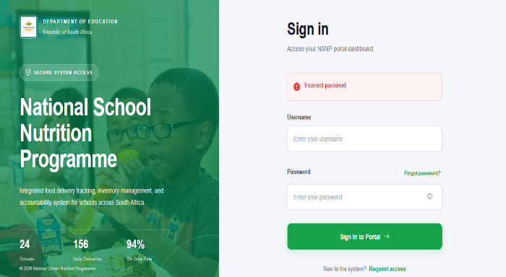
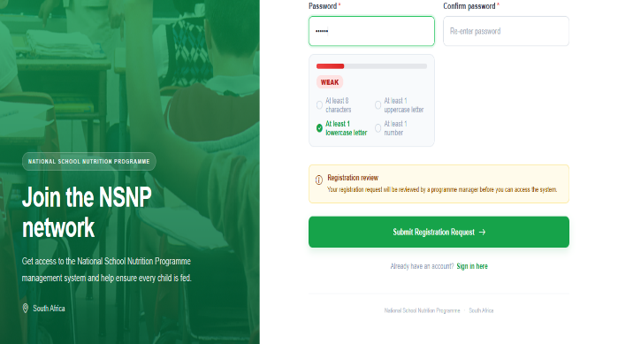
Figure 25: Authentication error message Figure 26: Password validation message

6. Testing and Evaluation

6.1 Testing strategy
Test type | Method
Automated functional, validation, security and access-control tests | Django TestCase with the test client (python manage.py test)
Manual UI, device and performance checks | Checklist on the live site (partly completed; remaining checks are future testing, Section 6.5)
Usability feedback review | Phase 3 feedback compared with the final system; post-implementation task times, error counts and SUS scores are future testing (Sections 6.4 and 6.5).

6.2 Automated test results
We ran the automated Django test suite on 11 October 2026 using Python 3.12 and Django 6.1 with an in-memory SQLite test database. The tests exercised views, templates, sessions and models. A faster password hasher was used only in the test settings.
Test class | Tests | Passed | Expected failures | What it covers
AuthenticationTests | 19 | 19 | 0 | Login for each role, wrong and unknown credentials, pending and rejected accounts, registration validation, password hashing, first-manager rule, approval, change password
AccessControlTests | 13 | 13 | 0 | Role redirects, pages render per role, session re-check, POST-only deletes, CSRF, SQL-injection attempt, script escaping, session lifetime
DeliveryTests | 15 | 15 | 0 | Manager create and assign, driver log and validation, Completed and Delayed, inventory update, notifications, staff confirm, school isolation, dashboard figures
InventoryTests | 10 | 10 | 0 | Add, edit, validation, low-stock alert once per day
IssueTests | 9 | 9 | 0 | Submit with photo, file type and size limits, required fields, priority default, manager status update and notification
ReportTests | 7 | 7 | 0 | Report KPIs, CSV, Excel and PDF downloads, date filter, invalid dates
NotificationTests / UserManagementTests | 3 | 3 | 0 | Mark read (own only), manager edits a role
KnownGapTests | 9 | 0 | 9 | Behaviour the design requires but the system lacks (Section 6.3)
Total | 85 | 76 | 9 | All 85 completed in 1.3 s; no unexpected failures

Coverage (measured with coverage.py): views.py 80% (916 statements, 181 not executed), models.py 91%. Expected failures are tests written for the intended behaviour that currently fail; they are marked expectedFailure so the suite stays green while each gap stays visible, and they will flag an "unexpected success" once a gap is fixed.
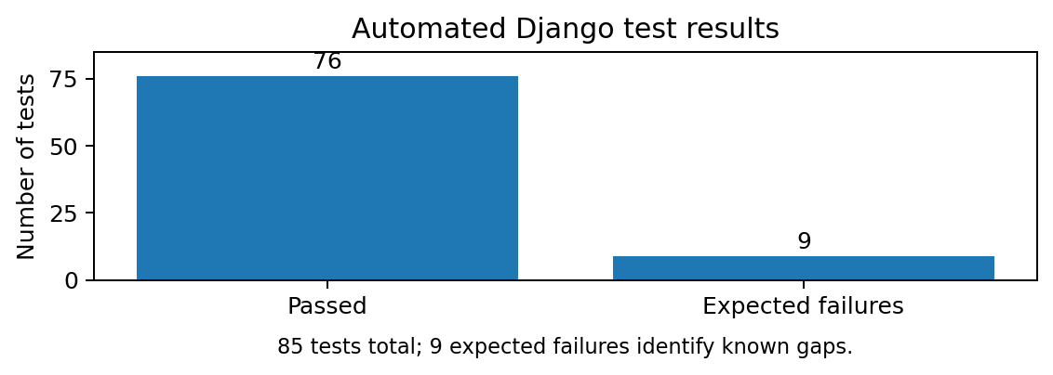

Figure 27: Automated test results
Test cases by identifier. The table lists the 41 tests in tests.py that carry a TC or SEC identifier (36 functional and 5 security). The other 44 tests have no identifier; they check supporting rules such as duplicate emails, invalid statuses, double confirmation and school isolation. All 41 passed on the 11 October 2026 run.
ID | Scenario tested | Expected result | Result
TC-01 | Valid login as driver, staff and manager | Each role is redirected to its own dashboard | Pass
TC-02 | Login with a wrong password | "Incorrect password." shown; no session created | Pass
TC-03 | Login with an unknown username | "Username does not exist." shown | Pass
TC-04 | Login with a Pending account | Blocked with the approval message; no session | Pass
TC-05 | Registration with different passwords | "Passwords do not match."; user not created | Pass
TC-06 | Registration with a weak password | Missing rules listed (length, uppercase); user not created | Pass
TC-07 | Registration with a duplicate username | "Username already exists." | Pass
TC-08 | Valid registration | Account saved as Pending; stored password differs from the entered one | Pass
TC-09 | Manager approves a pending user | Status becomes Approved; the user can log in | Pass
TC-10 | Driver opens manager pages | Redirected away from the dashboard, user management and create delivery | Pass
TC-11 | Anonymous access to 10 protected URLs | Every request is redirected to the login page | Pass
TC-12 | Manager creates and assigns a delivery | Saved as Pending with driver and recipient; driver notified | Pass
TC-13 | Manager delivery with quantity 0, -5, abc or blank | "Please enter a valid quantity."; nothing saved | Pass
TC-14 | Driver logs a valid delivery | Saved as Pending; confirmation notification created | Pass
TC-15 | Driver delivery with blank school or invalid quantity | Validation message shown; nothing saved | Pass
TC-16 | Driver marks a delivery Completed | Status Completed; inventory created (50 units); staff notified | Pass
TC-17 | Driver marks a delivery Delayed | Status Delayed; inventory unchanged; staff notified | Pass
TC-18 | Staff confirm a pending delivery | Status Completed; stock increases by the delivered quantity | Pass
TC-19 | Staff confirm another school's delivery | Refused; status stays Pending and stock is unchanged | Pass
TC-20 | Add an inventory item | Saved with quantity, minimum stock and batch reference | Pass
TC-21 | Add an inventory item with a negative quantity | Not saved; view returns "Quantities cannot be negative." | Pass
TC-22 | Edit an inventory item | Quantity and expiry date updated | Pass
TC-24 | Stock stays low after two completed deliveries | Exactly one low-stock alert per day sent to managers | Pass
TC-26 | Report an issue with a JPG photo | Saved as Open with High priority; photo stored; reporter notified | Pass
TC-27 | Attach an unsupported file type (.docx) | "Only PNG, JPG, JPEG and PDF files are allowed." | Pass
TC-28 | Attach a file larger than 10 MB | Size error shown; issue not saved | Pass
TC-29 | Report an issue with no description | "Please complete all required fields." | Pass
TC-30 | Manager sets an issue to Resolved | Status updated; reporter receives a notification | Pass
TC-31 | Download the delivery report as PDF | HTTP 200; file starts with the PDF signature | Pass
TC-32 | Download the inventory report as Excel | Spreadsheet content type; valid .xlsx archive | Pass
TC-33 | Download the inventory report as CSV | text/csv attachment with the expected columns and data | Pass
TC-34 | Driver opens Inventory and Reports pages | Redirected to the driver dashboard | Pass
TC-35 | Mark all notifications as read | Unread count becomes 0 | Pass
TC-36 | Manager changes a user's role | Role saved; user lands on the new dashboard at next login | Pass
TC-37 | Login with a Rejected account | Blocked with the approval message; no session | Pass
TC-38 | Change password | New password works and the old one is rejected | Pass
SEC-01 | POST without a CSRF token | HTTP 403 returned | Pass
SEC-02 | SQL-injection text in the login form | Treated as an unknown user; no session | Pass
SEC-03 | Script tag in an issue description | Output is escaped, so the script cannot run | Pass
SEC-06 | Delete a user or inventory item by GET, then POST | GET leaves the record; only POST deletes it | Pass
SEC-07 | Read the session lifetime setting | Records the implemented 3600 s value (target was 300 s) | Pass

6.3 Defects and gaps found by testing
ID | Finding | Severity | Status
D-1 | The report download endpoint (/reports/download/) has no role check: a driver can download all delivery, inventory and issue data even though the Reports page is restricted. | High | Not fixed
D-2 | A driver can report an issue against any delivery id; there is no ownership check. | Medium | Not fixed
D-3 | Inventory add-form validation errors are computed but inventory.html never displays them, so users get no feedback. | Medium | Not fixed
D-4 | Submitting an issue does not notify managers (requirement 3.8). | Medium | Not fixed
D-5 | A driver can mark a delivery Completed and update stock without staff confirmation. | Medium | Design gap
D-6 to D-9 | No automatic expiry notifications (3.6); 1-hour session instead of 5 minutes; no usage recording (3.5); no activity logging (3.11). | Medium | Design gaps

Known-gap tests mapped to defects. Each defect above has a test that describes the intended behaviour. All nine are marked expectedFailure and failed as expected, so each gap is confirmed by the suite and not only by reading the code.
Defect | Test (KnownGapTests) | Intended behaviour | Observed behaviour
D-1 | test_driver_cannot_download_reports | Report download is restricted like the Reports page | Driver receives the file (HTTP 200) instead of a redirect
D-2 | test_driver_cannot_report_issue_on_another_drivers_delivery | Issues only on the driver's own deliveries | Issue is saved for any delivery id
D-3 | test_add_inventory_error_message_is_visible_to_user | Validation error shown on the add form | Error is computed but never rendered in the template
D-4 | test_manager_notified_when_issue_submitted | Requirement 3.8: managers notified of new issues | No notification is created for managers
D-5 | test_driver_cannot_complete_delivery_without_staff_confirmation | Only staff confirmation updates stock | Driver completion creates the inventory record
D-6 | test_expiring_stock_creates_notification | Requirement 3.6: automatic expiry alert | No expiry notification is created
D-7 | test_session_expires_after_five_minutes | NFR: auto-logout after 5 minutes | Session lasts 3600 s
D-8 | test_usage_can_be_recorded | Requirement 3.5: daily usage recording | No usage-recording feature in the application
D-9 | test_activity_is_logged | Requirement 3.11: activity logging | No activity logging in the application

Conclusions from the automated tests.
- The core workflow works. The 76 passing tests cover login and role routing, registration with manager approval, delivery creation, status changes, automatic inventory updates, the once-per-day low-stock alert, issue reporting with attachment limits and the CSV, Excel and PDF exports. The central NSNP process behaves correctly from end to end in the test environment.
- Validation is consistent. Invalid quantities, missing fields, weak passwords, duplicate usernames and emails, unsupported or oversized files and unknown statuses are all rejected without saving data or causing a server error (TC-05 to TC-08, TC-13, TC-15 and TC-27 to TC-29).
- Business rules hold between users. A driver cannot change another driver's delivery, staff cannot confirm another school's delivery, a delivery confirmed twice adds stock only once, school names match regardless of case, and a driver cannot change an issue status.
- Security basics are in place, with one caveat. CSRF is enforced (SEC-01), an SQL-injection string fails as an unknown user (SEC-02), script tags are escaped (SEC-03), deletes need POST (SEC-06) and approval is re-checked on every request. SEC-07 passes only because it records the current 1-hour session; it does not show that the 5-minute target is met, which is why D-7 fails.
- Some passes record current behaviour, not full success. TC-21 passes because the view produces the message, yet D-3 shows the user never sees it. The upload tests use small generated files and accept a fake JPEG payload, which suggests the file check relies on the declared type and not on the file content.
- The failures are known and fall into two groups. D-1 to D-4 are small code fixes. D-1 matters most because any logged-in driver can download all delivery, inventory and issue data, so it should be fixed before real school data is loaded. D-5 to D-9 need design decisions or new features (usage recording and activity logging).
- The tests have limits. They run through the Django test client on in-memory SQLite with a fast password hasher. They do not check browser rendering, JavaScript (charts, password meter), mobile layout, performance or PostgreSQL behaviour, and about 20% of views.py is never executed. The manual checks in Sections 6.4 and 6.5 are still needed.
Overall: the suite gives good confidence in the functional core and an honest list of what is missing. The system is a sound prototype, but it is not ready for real school data until D-1 to D-4 are resolved.

6.4 User feedback and usability evaluation
We reviewed the feedback gathered during Phase 3 and compared it with the features in the final system. The report does not contain a complete set of timed post-implementation user trials or SUS scores, so we have not made up task times or satisfaction ratings. The tasks below are suitable for a follow-up usability test with drivers, school staff and the manager (Nielsen, 1993). The Phase 2 target was for common tasks to take less than 60 seconds.
ID | Role tested | Background | Device | SUS (0–100) | Satisfaction (1–5)
P1 | Lesedi | Driver; Phase 3 feedback | Future testing | Future testing | Future testing
P2 | Linda | School staff; Phase 3 feedback | Future testing | Future testing | Future testing
P3 | Karabo | Manager; Phase 3 feedback | Future testing | Future testing | Future testing

Task | Role | Description | Target (s) | Avg time (s) | Completed unaided | Errors (avg)
T1 | Driver | Log in and log a new delivery | 60 | Future testing | Future testing | Future testing
T2 | Driver | Mark a delivery Completed | 30 | Future testing | Future testing | Future testing
T3 | Driver | Report damage with a photo | 60 | Future testing | Future testing | Future testing
T4 | Staff | Confirm a pending delivery | 30 | Future testing | Future testing | Future testing
T5 | Staff | Find low-stock items | 30 | Future testing | Future testing | Future testing
T6 | Manager | Create and assign a delivery | 60 | Future testing | Future testing | Future testing
T7 | Manager | Approve a pending registration | 30 | Future testing | Future testing | Future testing
T8 | Manager | Set an issue to In Progress | 30 | Future testing | Future testing | Future testing
T9 | Manager | Download the issues report as CSV | 45 | Future testing | Future testing | Future testing
Completion rate = participants finishing unaided ÷ participants attempting × 100. Error rate = total errors ÷ attempts. SUS (Brooke, 1996): for odd items score = rating − 1, for even items 5 − rating; sum the ten scores and multiply by 2.5. Satisfaction questions (rate 1–5): easy to learn; fast to complete tasks; error messages clear; colours and layout clear; confident my data was recorded; better than the paper/phone process.

Phase 3 feedback compared with the final system
User | Phase 3 feedback | Final system | Status
Lesedi (Driver) | No workload overview; information spread over pages | Dashboard with today's counts, completion % and next delivery; form, list and issues on one page | Addressed
Lesedi (Driver) | No image attachments; no notification area | Photo or PDF attachment on issues; notifications page with unread badge | Addressed
Linda (School Staff) | Crowded list, no colour coding; no severity on issues | Colour-coded status badges Status badges are displayed and issues have Low/Medium/High priority | Partially addressed
Linda (School Staff) | Could not see stock after confirming | Stock table with Low Stock / Adequate on dashboard and Inventory page | Addressed
Linda and Karabo | Account creation depended on administrators | Self-registration; manager approval still required | Partially addressed
Karabo (Manager) | No graphs, no report generation | Dashboard and Reports charts; PDF, Excel, CSV export | Addressed
Karabo (Manager) | No central notifications; long tables | In-app notifications only; table layout The layout still needs usability review | Partially addressed

Changes made in response to Phase 3 feedback
Problem observed | Feedback source |  | Change made | Re-test result
Users wanted a clearer view of delivery workload and stock. | Phase 3 feedback from Lesedi and Linda. |  | Added role dashboards, delivery summaries, inventory indicators, issue attachments and report charts. | Features are present in the final system. A timed post-implementation re-test is future testing.

6.5 Compatibility, performance and contrast
Check | Target | Result
Chrome / Edge / Firefox on desktop | Pages load, forms usable | Website loaded and dashboard was accessible in Chrome on desktop; Edge and Firefox are future testing.
Phone (Android or iPhone) and tablet | Layout correct, forms usable, photo upload works | Future testing.
Login page load time | < 2 s | Future testing.
Driver, staff and manager dashboards load time | < 5 s | Future testing.
Reports page load time | < 5 s | Future testing.
Contrast of body text, buttons and status badges (WebAIM checker) | ≥ 4.5:1 (WCAG 2.1 AA; World Wide Web Consortium, 2018) | Future testing (WebAIM contrast checker).
Downloaded PDF, Excel and CSV open correctly | Correct columns and data | Automated tests passed for PDF, Excel and CSV export in the test environment.
Future testing. The checks marked “Future testing” in Sections 2.7, 6.4 and 6.5 were not completed within the project timeframe. They are planned as the next testing stage and will be added to this report once done:
- Usability trials. Run tasks T1 to T9 (Section 6.4) with drivers, school staff and the manager, and record task times, errors, unaided completion, SUS scores (Brooke, 1996) and satisfaction ratings against the Phase 2 targets.
- Performance and load. Measure login, dashboard and reports load times against the 2 s and 5 s targets and test 100 concurrent users on the deployed site, including Render free-tier cold starts.
- Availability. Monitor uptime over a defined period against the 99% target.
- Compatibility and mobile. Test Chrome, Edge and Firefox, and Android, iPhone and tablet layouts, including photo upload from a phone.
- Accessibility. Measure the contrast of body text, buttons and status badges with the WebAIM checker against 4.5:1 (World Wide Web Consortium, 2018) and complete an accessibility audit.
- Security and data. Add regression tests when D-1 to D-4 are fixed, check uploaded files by content as well as declared type, and run the suite against PostgreSQL as well as SQLite.
- Automation. Run the Django test suite automatically on GitHub for every commit and add browser tests for JavaScript features such as the charts and password strength meter.

7. Demonstration

7.1 Video storyboard
The video demonstration of the deployed NSNP Food Distribution and Tracking System was recorded on 12 October 2026 (Mokoena et al., 2026). It follows the workflow described in Section 2.1 for the manager, driver and school staff dashboards. Video link: https://solplaatjeuniversity-my.sharepoint.com/:v:/g/personal/202306895_spu_ac_za/IQA8xtyX_h_mR6Y2kGHhbKeYAWyIr4EP6E1tyTH-ucBN464?e=Uw6U9j.
Note: the video is hosted on the university SharePoint account. If the link does not open, the video file is named “Mon Oct 12 2026 7_15_11 PM.webm” and can be supplied on request.

7.2 Technical decisions to explain
- Why Django: built-in security (CSRF, hashing, escaping), ORM and fast delivery of three role-based dashboards.
- Why PostgreSQL in production: managed on Render, supports concurrent users; SQLite keeps local setup simple.
- Why manager approval for registration: keeps control of who may see school data after moving from administrator-issued accounts to self-registration.
- Why the schema was simplified: during implementation we focused on the main delivery, inventory, issue and notification workflows. This reduced the scope, but it also meant the final models did not fully match the planned ERD.
- Why email is disabled: Render's free tier blocks outbound SMTP, so in-app notifications are used.

7.3 Anticipated supervisor questions
Question | Answer
Can a driver confirm their own delivery? | Yes. The driver can mark a delivery Completed, which also updates inventory. This weakens independent verification; the fix is to restrict inventory updates to staff confirmation.
Where is the audit trail? | There is no audit table yet. Per-user accounts and timestamps give partial accountability; an ActivityLog model is planned.
How are passwords protected? | They are hashed with Django's password hasher and validated for strength at registration.
What happens to uploaded photos on redeploy? | Media is stored on the server file system. On a free plan this storage may not persist, so cloud storage is a recommended improvement
How did user feedback change the system? | The system adds issue attachments, priority, charts, reports, notifications and self-registration, each traced to feedback.
How did you test? | The project has automated Django tests as well as manual checks. The automated suite recorded 76 passes and 9 expected failures that identify known gaps. Formal timed usability results are future testing (Section 6.4).

8. Results and Discussion

8.1 Phase 1 problems versus the delivered system
Phase 1 pain point | How the system addresses it | Outcome
Manual stock tracking in notebooks | Digital inventory updated from deliveries, with manual correction and minimum-stock indicators | Implemented
Delayed reporting by phone | Issue form with priority and photo; status tracking; notifications to the reporter | Implemented
Food theft with no accountability | Individual accounts and records of driver and reporter; no full audit log yet | Partial
No expiry monitoring | Expiry date and days remaining are visible; no automatic alerts | Partial
No usage data compared with supply | Delivery and stock data available; consumption is not recorded | Not implemented
Ineffective delivery schedules | Managers schedule date, time, driver and recipient; delays are recorded manually | Partial
No central visibility for managers | Manager dashboard, reports and exports across schools | Implemented

8.2 Discussion
The main goal from Phase 1 was to make delivery and stock information easier to record and monitor instead of relying only on notebooks and phone calls (World Food Programme Centre of Excellence against Hunger Brazil, 2022). We achieved much of this by building a web system where the manager can assign deliveries, drivers can update delivery status, school staff can confirm deliveries, inventory is updated, issues can be reported, and reports can be exported.
We did not complete every feature planned in Phase 2. The system still needs a full activity log, daily food-usage recording, automatic expiry and delay alerts, and stricter separation between a driver's delivery update and school staff confirmation. The current version improves visibility, but these gaps limit how strongly it can support accountability.

9. Limitations and Future Improvements

9.1 Limitations
- Automated tests cover the main workflows, but manual browser, device, performance and usability checks are still limited and are planned as future testing (Section 6.5).
- No activity log and no daily usage recording (Phase 2 requirements 3.11 and 3.5).
- Expiry and delay alerts are not automatic; expiry is shown but does not trigger a notification, and delays are set by hand.
- Weak data integrity: school and food names are free text, so spelling differences can split records; one food item per delivery.
- Verification gap: the driver can mark a delivery Completed and update inventory without school staff confirmation.
- Session timeout is one hour, not the 5 minutes in the non-functional requirements.
- Notifications are in-app only and update on page load; email is disabled on the free hosting tier, so password reset by email is unavailable.
- Security hardening: no login throttling, informative login errors reveal valid usernames, and development fallbacks and seed credentials exist in source code.
- Hosting limits: free-tier cold starts and possibly non-persistent media storage.
- Placeholder values: the staff dashboard's "learners fed" is fixed and its weekly chart shows deliveries rather than consumption.
- Scalability: unpaginated lists and repeated queries; not load tested.
- Accessibility and language: no formal accessibility audit; English only.
- Formal post-implementation usability trials are future testing; the design feedback came from three Phase 3 reviewers.

9.2 Future improvements
Priority | Improvement | Benefit
High | Extend the existing Django tests (browser, device, performance and usability testing) and run them automatically on GitHub | Regression safety and testing evidence
High | Add ActivityLog model written from every create, update and delete action | Fulfils the accountability and anti-theft goal
High | Only school staff confirmation updates inventory; driver status becomes "Delivered (awaiting confirmation)" | Independent verification of receipt
High | UsageRecord model and daily usage form that deducts stock | Compare supply with consumption
High | Normalise School, FoodItem, Supplier and Role tables; migrate existing text data | Data integrity and better reports
Medium | Scheduled job for expiry and overdue-delivery notifications | Automatic alerts as designed
Medium | Notify managers when an issue is submitted | Completes requirement 3.8
Medium | 5-minute inactivity logout, login throttling, generic login errors, environment-only secrets | Meets security NFRs
Medium | Cloud media storage (for example S3-compatible) and a paid or always-on hosting plan | Persistent uploads, better availability
Medium | Email delivery through a provider API (HTTP-based) and email password reset | Works within hosting limits
Low | Offline-tolerant driver mode, SMS alerts, additional South African languages | Fit for rural connectivity and users
Low | Accessibility audit and pagination | Inclusive and scalable interface

10. Reflection: Designing for Humans

10.1 What we learned
- Real users change priorities. The Phase 3 reviewers asked for photo attachments, severity levels, charts and reports, none of which were in our first feature list. Those requests became some of the most useful parts of the system.
- Context shapes the interface. Drivers work at school gates and schools may have limited connectivity, so short forms, clear summaries and a mobile-friendly layout matter more than feature volume.
- Error messages are part of the interface. Specific messages ("Password must contain at least 1 uppercase letter") removed guesswork, but we learned that helpful messages can conflict with security (for example revealing that a username exists).
- Trust and control pull in different directions. Moving from administrator-issued accounts to self-registration reduced workload but forced us to add an approval step so that unknown people cannot see school data.
- Design documents can drift from the code. Our Phase 3 ERD planned 12 entities, but we simplified the final implementation to five main models. We should have updated the design documents as soon as that decision was made.

10.2 What surprised us
As a group, we were surprised by how connected the features were. A small change to a delivery status could affect inventory, notifications and the information shown on the dashboards. We also found that getting the application running and deployed took more time than expected. The design looked straightforward on paper, but testing showed that access rules, data consistency and clear feedback needed just as much attention as the screens themselves.

10.3 What we would change based on user feedback
- Build the audit log and usage tracking earlier, since accountability was the original reason for the project.
- Test with real drivers and school staff before building additional features, not only after the first prototype.
- Write automated tests from the first sprint instead of relying on manual checks.

10.4 Group contributions
As a group, we took the project from defining the school feeding tracking problem to planning the system, designing the data and screens, building the Django application, testing the main workflows and documenting the final result. We had to make decisions when the original design was too large for the time available. The final system does not include every planned feature, but the work helped us understand how requirements, database design, implementation and testing need to stay connected.

11. Conclusion
In Phase 1, we identified problems with paper-based delivery records, late reporting, stock accuracy and limited accountability. In Phase 2, we defined the requirements and designed the system. In Phase 3, we prepared the prototype and data design and considered feedback from Lesedi, Linda and Karabo. In Phase 4, we implemented and deployed a Django web application with role-based access, delivery logging, delivery status updates, inventory management, issue reporting, notifications and report exports. The automated tests also gave us evidence that the main workflows and several security checks work in the test environment.
We therefore achieved the main purpose we set out in Phase 1: we built a working system that brings delivery, stock, issue and reporting information into one place. However, we cannot say that every original requirement has been met. Activity logging, daily usage recording, automatic expiry and delay alerts, a five-minute session timeout and some access-control fixes remain outstanding. Our conclusion is that the project is a working prototype and a useful step away from manual tracking, but it needs these improvements and more real-user testing before it should be used with real school data.

References
Brooke, J. (1996) 'SUS: a quick and dirty usability scale', in Jordan, P.W., Thomas, B., Weerdmeester, B.A. and McClelland, I.L. (eds) Usability Evaluation in Industry. London: Taylor & Francis, pp. 189–194.
Department of Basic Education (2024) Internal government documents on National School Nutrition Programme supply chain inefficiencies. Pretoria: Department of Basic Education. (August).
Django Software Foundation (2026) Django documentation. Available at: https://docs.djangoproject.com/ (Accessed: 11 October 2026).
Mokoena, K., Molomo, K., Thabethe, K. and Thuto, H. (2026) NSNP Food Distribution and Tracking System: demonstration video [Video recording]. Sol Plaatje University. Available at: https://solplaatjeuniversity-my.sharepoint.com/:v:/g/personal/202306895_spu_ac_za/IQA8xtyX_h_mR6Y2kGHhbKeYAWyIr4EP6E1tyTH-ucBN464?e=Uw6U9j (Accessed: 12 October 2026).
Nielsen, J. (1993) Usability Engineering. San Diego: Academic Press.
Qila, V.E. and Tyilo, N. (2014) 'Implementing National School Nutrition Programme (NSNP): how involved are the stakeholders', Mediterranean Journal of Social Sciences, 5(27), pp. 381–390.
Render (2026) Render documentation. Available at: https://render.com/docs (Accessed: 11 October 2026).
World Food Programme Centre of Excellence against Hunger Brazil (2022) Using digital tools to strengthen South-South cooperation in school feeding. Brasília: WFP Centre of Excellence against Hunger.
World Wide Web Consortium (2018) Web Content Accessibility Guidelines (WCAG) 2.1. Available at: https://www.w3.org/TR/WCAG21/ (Accessed: 11 October 2026).

